🧑‍💼 AttendEase – Admin Panel (Final Design Specification)

🎯 1. Objective
The Admin Panel acts as the central control system for AttendEase, enabling:
- Monitoring attendance across institution
- Exploring hierarchical data (Dept → Teacher → Course → Student)
- Managing users and integrity (blocking, device control)
- Generating reports
- Facilitating communication (externally via Gmail)
- Configuring system-level rules

🧭 2. Navigation Structure (Sidebar)

Sections:
- 🏠 Dashboard
- 📊 Records
- 👥 Users
- 📩 Communication
- 📱 Device Requests
- 📑 Reports
- ⚙️ Settings

🏠 3. Dashboard

🎯 Purpose:
Provide quick system overview + trends
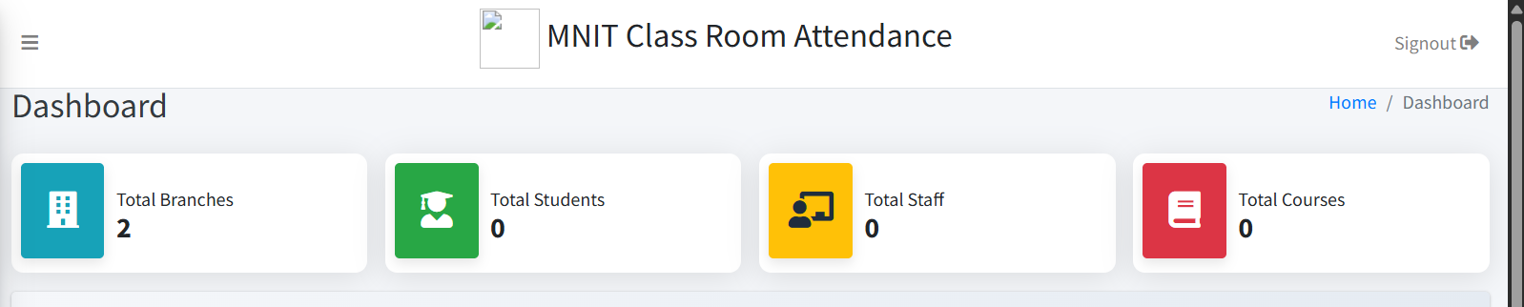

🔹 Components

A. Summary Cards
- Total Students
- Total Teachers
- Active Courses
- Average Attendance %
- Low Attendance Count (< threshold)
- Pending Device Requests

B. Attendance Session Graph
- Graph type: Line chart
- Data:
  - Number of attendance sessions conducted
- Time filters:
  - Weekly
  - Monthly
  - Yearly

C. Insights
- Branch-wise attendance comparison
- Students registered gender wise pecentage
- Top/lowest performing courses
Reference Images:
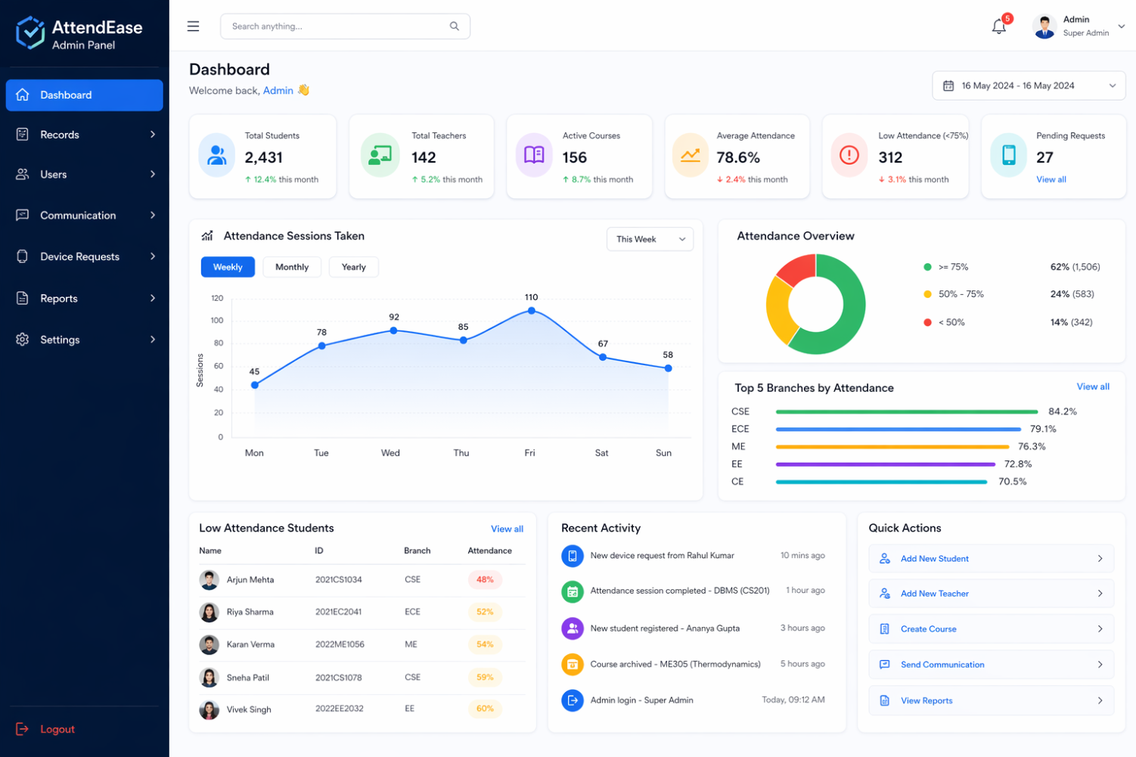

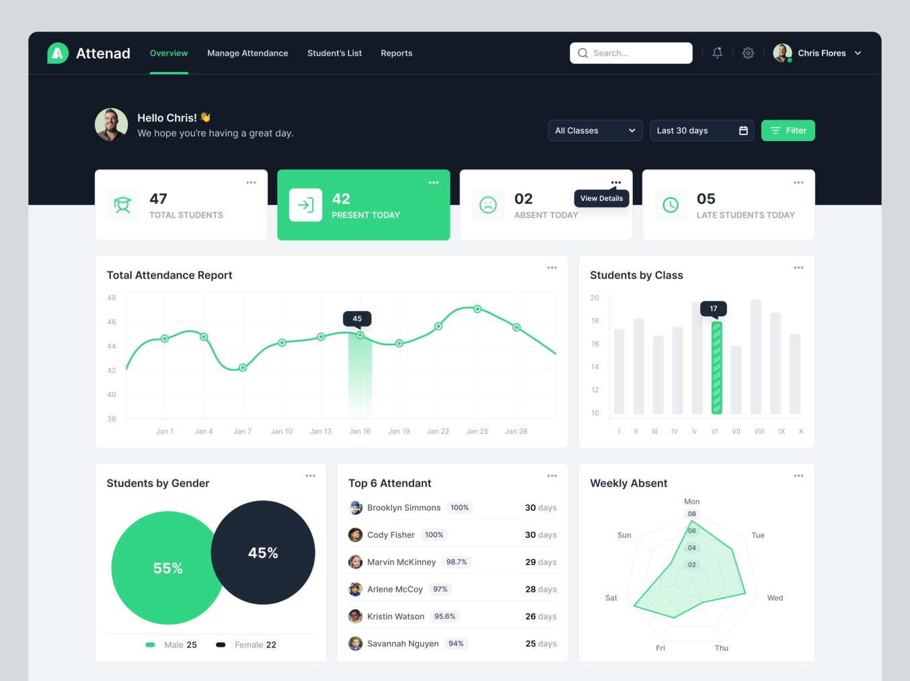

📊 4. Records (Core Module)

🎯 Purpose:
Enable hierarchical exploration of attendance data

🔹 Key Features
- Drill-down navigation
- Breadcrumb tracking
- Course-level actions (archive/unarchive)
- Course search via course code

🔹 UI Structure

A. Breadcrumb Navigation
Department > Teacher > Course > Students

B. Level-wise Views

1. Department View
- Display as cards:
  - Department Name
  - Total Students
  - Average Attendance %

2. Teacher View
- Table:
  - Teacher Name
  - Courses handled
  - Avg attendance

3. Course View
- Cards/Table:
  - Course Name
  - Students count
  - Classes taken
  - Avg attendance
  - Last attendance session timestamp

🔸 Special Cases:
- Archived courses:
  - Display in greyed-out style
  - Action available: Unarchive
- Active courses:
  - Action: Archive

4. Student View
- Table:
  - Name
  - ID
  - Attendance %
  - Status (Low/Normal)

🔹 Side Stats Panel (Dynamic)
- Avg attendance
- Classes taken
- Low attendance count

🔹 Search
- Course Code search (global inside Records)

👥 5. Users (Unified Student + Teacher Management)

🎯 Purpose:
Search, inspect, and control users
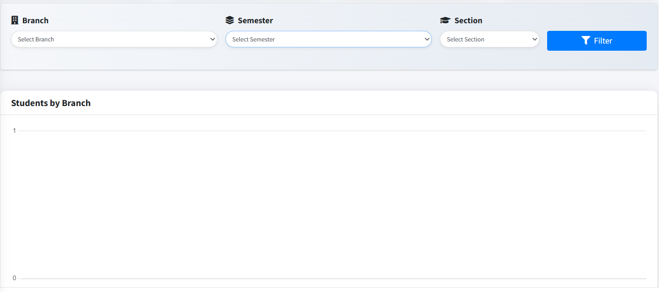

🔹 Layout

A. Tabs
- Students
- Teachers

B. Filters
- Degree (BTech/MTech)
- Branch
- Semester
- Section

C. Search
  - Can search entering Name or ID.

D. Table View
Columns:
- Name
- ID
- Role
- Attendance %
- Enrollment Date
- Status (Active/Blocked)

🔹 User Profile View

A. Basic Info
- Name
- ID
- Role
- Enrollment Date
- Last activity timestamp

B. Attendance Overview
- Overall %
- Visual indicator (progress bar)

C. Courses Table
- Course Name
- Attendance %
- Classes attended

D. Actions
- Block Student (only for students)

📩 6. Communication (Gmail Integration Flow)

🎯 Purpose:
Assist admin in sending structured communication externally

🔹 Key Concept:
System does NOT send email directly
→ It prepares Gmail draft

🔹 Flow

Step 1: Filters
- Degree
- Branch
- Semester
- Course
- Attendance Threshold

Step 2: Audience Selection
- Student
- Parent

Step 3: Auto Data
- System fetches:
  - Email IDs

Step 4: Compose Box
Fields:
- To (auto-filled emails)
- CC (editable)
- BCC (editable)
- Subject (auto-generated, editable)
- Body:
  - Default message based on threshold
  - Editable

Step 5: Preview Panel
- Full email preview shown before sending

Step 6: Action
- Button: Proceed to Gmail
👉 Opens Gmail with:
- Pre-filled To, CC, BCC
- Subject
- Body

📱 7. Device Requests

🎯 Purpose:
Control device-based authentication integrity

🔹 Table View
- Student Name
- ID
- Old Device (MAC)
- New Device
- Request Timestamp

🔹 Features
- Approve / Reject request
- Search by name / ID

🔹 Additional Insight
- Show:
  - Number of previous device requests per student
- Expand row → view:
  - Full request history

📑 8. Reports

🎯 Purpose:
Export structured attendance data

🔹 Report Types
- Student Report
- Teacher Report
- Course Report

🔹 Filters
- Date Range (From → To)
- Branch
- Course

🔹 Output
- Excel download
- Format:
  - Each subject → separate sheet

⚙️ 9. Settings

🎯 Purpose:
System configuration + admin control

🔹 Sections

A. Academic Config
- Manage:
  - Branches
  - Sections

B. System Config
- GPS Radius
- QR Refresh Interval
- BLE Threshold

C. Admin Management
- Add Admin
- Remove Admin

D. Security
- Change Password

🎨 10. UI/UX Guidelines

🔹 Layout
- Left collapsible sidebar
- Top bar with:
  - Search
  - Profile
  - Notifications

🔹 Design Rules
- Card-based layout for summaries
- Tables for detailed data
- Consistent spacing and padding
- Avoid deep nested clicks (>3 levels)

🔹 Color Rules
- Blue → Primary
- Green → Good
- Red → Alert
- Grey → Archived / inactive

🔹 UX Enhancements
- Breadcrumb navigation
- Sticky filters
- Loading states
- Empty states
- Tooltips for actions

🧱 11. Frontend Component Architecture

🔹 Core Components
- Sidebar
- Topbar
- Card
- Table
- FilterBar
- Breadcrumb
- Modal

🔹 Feature Components
- RecordsExplorer
- UserProfile
- CommunicationComposer
- DeviceRequestManager
- ReportGenerator
- SettingsManager

🧠 12. Backend Requirements (for clarity)
- User DB (students, teachers, admins)
- Course + mapping DB
- Attendance logs
- Device mapping (MAC tracking)
- Request logs (device changes)
- Config table (GPS, QR settings)

🚀 Final Summary
This admin panel is designed to:
- Handle large-scale institutional data
- Provide hierarchical exploration
- Ensure security via device + attendance monitoring
- Enable actionable insights + communication

💡 One-line Product Definition
“A centralized, scalable admin dashboard enabling secure attendance monitoring, hierarchical data exploration, and intelligent communication for academic institutions.”

